Kathford International College of Engineering and Management
Balkumari, Lalitpur, Nepal

A
Project Proposal
On

College Management System with Machine Learning based Grade Prediction

Submitted To
Department of Information Technology
Kathford International College of Engineering and Management

In partial fulfillment of the requirement for the Bachelor’s Degree in Computer
Science and Information Technology

Submitted By
Abhinav Singh Thapa (79010398)
Babita Subedi (79010404)
Khusi Dahal (79010410)

Submitted on: 2082/11/01
Table of Contents
1. Introduction 1
2. Problem Statement 1
3. Problem Objectives 2
4. Methodology 3
4.1. Requirement Identification 3
4.1.1. Study of Existing System/Literature Review 3
4.2. Requirement Analysis 4
4.2.1. Functional Requirements 4
4.2.2. Non-Functional Requirements 4
4.3. Feasibility Study 7
5. Timeline 8
6. Description of Algorithm 8
6.1. Random Forest 8
6.2. Linear Regression 9
7. Methodology 9
8. Expected Output 10
9. References 11

Introduction
Educational institutes mostly rely on traditional manual methods for recording attendance and student record keeping. Also, system to predict student outcomes or identify those at risk of poor performance isn’t prevalent. This often leaves struggling students unnoticed until final assessments as the system isn’t in place.
College Management System is a web application integrated with Machine Learning to predict final grades (G3) and manage student records. Teachers will enter student records like attendance, assignment submissions, periodic assessment marks (G1, G2), which will securely store all student records in a centralized database. Administrators will manage student registration.
The system employs Linear Regression and Random Forest models to predict final grades. For every student, identification of the most influential factors affecting performance will be done by random forest model, and insights will be provided to help them improve their final grades.
By highlighting areas where students need improvement and indicating which factors most impact their outcomes, the system enables early identification of at-risk students. By combining digital record keeping with predictive analytics, this solution transforms traditional manual monitoring into a practical web solution.

Problem Statement
Educational institutes mostly rely on traditional manual methods for recording attendance and student record keeping. Struggling students often go unnoticed until final assessments, as systems to predict outcomes or identify at-risk performers remain rare.
Although some digital management tools exist, many don’t integrate predictive analytics to provide insights. Systems typically store data without modeling, leaving teachers and administrators without early warnings on performance risks. Also, systems to pinpoint and give insights like which influential factors (attendance, assignments) influence the student the most and how they can improve the final grades are rare.
There is a clear need for a system that:
- Replaces manual student record keeping with web-based solution
- Uses Machine Learning (Linear Regression and Random Forest) to predict final grades (G3)
- Identifies key performance factors for each student and delivers grade improvement insights
- Facilitates early detection of at-risk students to boost outcomes

Problem Objectives
- To eliminate manual student records by providing a web-based system to store student records
- To enable accurate final grade prediction (G3) using machine learning models for every student.
- To deliver targeted insights by identifying the most influential performance factors (e.g., attendance, assignments) and recommending actionable steps to improve outcomes for every student.

Methodology

Requirement Identification

Study of Existing System/Literature Review
The integration of Machine Learning (ML) into educational systems has significantly enhanced the capability to predict student academic performance and identify at-risk learners at early stages.
Ensemble learning techniques, particularly Random Forest (RF), have demonstrated superior performance in academic prediction tasks. Agyemang et al. [1] reported that RF achieved higher predictive accuracy compared to alternative machine learning approaches due to its ability to capture nonlinear relationships and reduce overfitting through bootstrap aggregation. Similarly, Xu and Yang [4] concluded that RF outperforms Multiple Linear Regression (MLR) when interdependencies exist among factors.
Despite RF’s strong predictive power, Linear Regression (LR) remains widely used because of its simplicity and clear description. Kayes et al. [5] emphasized that LR provides clear explanations, allowing educators to understand how factors such as attendance and prior grades influence final academic outcomes in simple way.
Research in IEEE Transactions on Learning Technologies [3] highlights the use of predictive analytics to identify students at risk of dropout through early academic signals. Moreover, AI-driven student success predictors discussed in Computers in Human Behavior [2] demonstrate high forecasting accuracy when sufficient and well-structured data is available, making the systems accurate and results easy to determine.
Existing Nepali platforms such as Paathshala [6] provide essential College Management System (CMS) functionalities including student profile management, attendance tracking but they do not integrate machine learning-based grade prediction or early warning analytics for identifying academically at-risk students. In many Nepali colleges digital systems mainly store records but do not analyze them. This creates a gap between data collection and meaningful academic insight.

Requirement Analysis

Functional Requirements
i. User Registration & Authentication
- Secure account creation and login for teachers and administrators..
ii. Teacher Data Entry
- Input student attendance, G1/G2 marks, and assignment submissions.
iii. Admin Student Management
- Register new students and manage student profiles.
- Manage teacher accounts and student records
iv. Grade Prediction (G3)
- Predict final grades using Random Forest or Linear Regression model
v. Performance Factor Analysis
- Random Forest model feature function identifies the most influential factor for each student
- Insights is given to help student by working on the factors which causes grade depletion

Non-Functional Requirements
Reliable data storage: Safe database that stores data in a reliable way and doesn’t loses entries.
Fast Prediction System: Grade predictions show in under 30 seconds, pages load quickly
Authentication: Safe login for teachers/admins.
Uptime: System available 99% of time.
Performance: Works smoothly for 5 teachers using it at once, handles 50 students and the model data should be accurate enough to be trusted it in the future
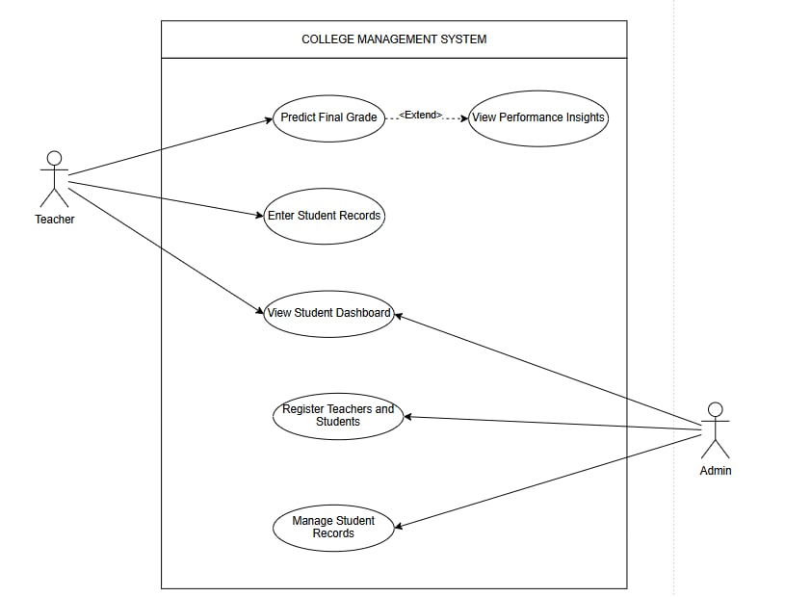

Figure 1: Use Case Diagram

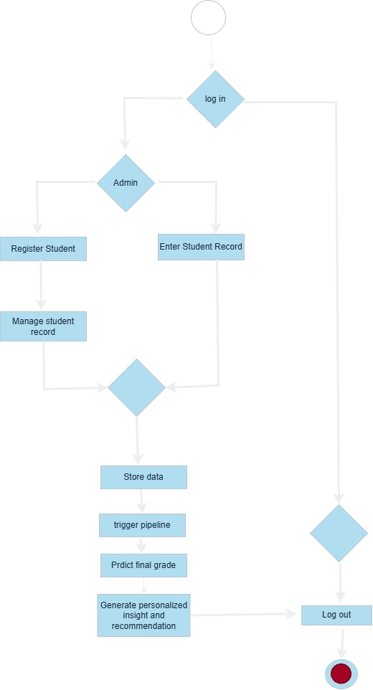
Figure 2: Flowchart

Feasibility Study
- Technical Feasibility
The project uses open-source, free, well-established technologies with ample resources over the internet. React.js handles the responsive web frontend, Node.js with Express manages backend logic and APIs, while SQLite/PostgreSQL ensures reliable data storage for student records. Scikit-learn implements the Linear Regression and Random Forest ML models. These technologies are technically feasible for college project.
- Operational Feasibility
The web-based system is simple to use and doesn't require technical expertise Teachers input student records easily, administrators handle registrations, this is all done in a user-friendly web-based forms. This can be adopted easily in campus environment.
- Economic Feasibility
There is no requirement of external hardware apart from student devices. Also, all the technologies being used (React, Nodejs) and hosting services will be free to use. Datasets to train the model will also be extracted from open source. Hence it is economically feasible.

Timeline
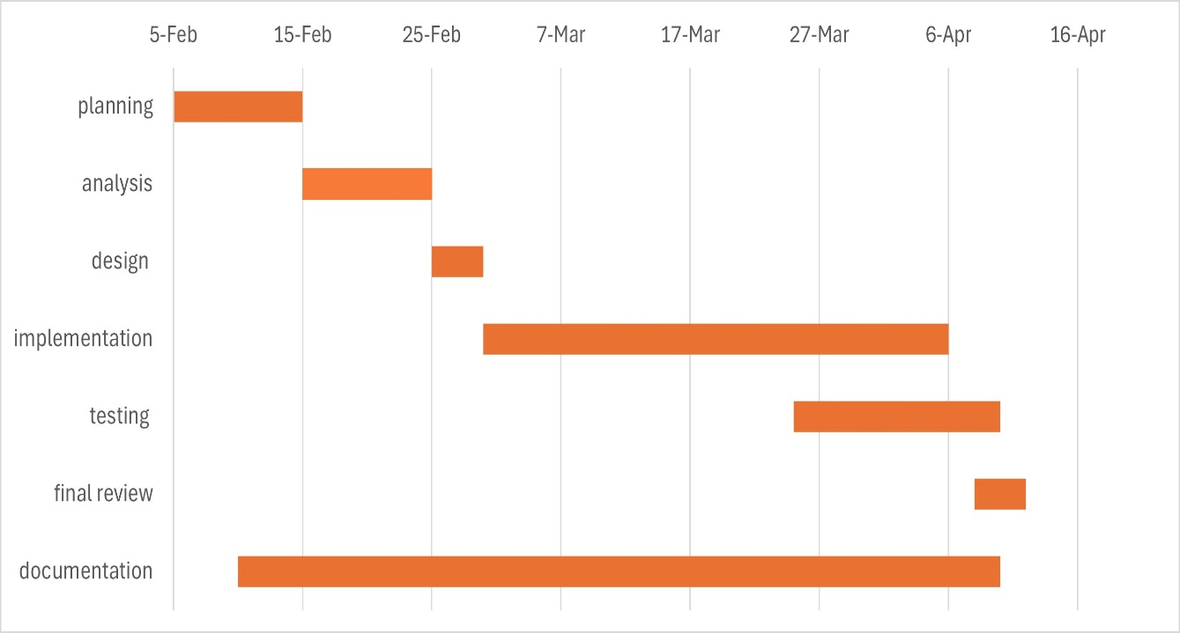
Figure 3: Gantt Chart

Description of Algorithm

Random Forest
Random Forest is a supervised machine learning algorithm based on ensemble learning technique. It constructs multiple decision trees during training and outputs the average prediction (for regression) or majority vote (for classification). Different random samples of the data, and their predictions are combined to reduce variance and improve accuracy. And each tree is trained on random subsets of data.
Random Forest also provides feature prediction, which identifies which input variables (features) significantly influence the target variable. It is calculated based on how much a feature reduces impurity or error across all decision trees. Hence, due to its high accuracy, ability to handle missing and noisy data, and good compatibility with structured dataset random forest is used.

Linear Regression
It is a supervised learning algorithm used to predict a continuous numerical value by modeling a linear relationship between independent variables and a dependent variable. Encoding of binary data, and categorical data will be done to fit the relationship, whereas continuous data can be used as it is.
The general equation of multiple linear regression is:
$$Y=β_{0}+β_{1}X_{1}+β_{2}X_{2}+⋯+β_{n}X_{n}+ϵ$$
where $Y$is the target variable and $X_{1},X_{2},...,X_{n}$are input features, $β_{0}$is the intercept, $β_{i}$are regression coefficients, the error term. It gives upmost accuracy if the relationship between Y (final result) and input features X (attendance, past grades) etc is linear in nature.

Methodology
Agile development model will be used as the software development methodology for the College Management System. As its iterative nature allows different modules and features to be added incrementally. In the initial sprint, student record management will be implemented. After this, Machine Learning components will be added in subsequent sprints. Finally, in the last sprints, integration will be completed and the User Interface is refined along with hosting.

Expected Output
This project produces web-based College Management System to manage student record with Machine Learning Prediction that digitizes manual record-keeping and guides teachers/admins in student support by predicting their final grades and providing insights as to which factor to improve in order to improve grades.

References
[1] S. Agyemang, E. O. Appiah, and E. A. Yirenkyi, “Predicting Students' Academic Performance Via Machine Learning Techniques,” ScholarWorks@UTRGV, 2023.
[2] “AI student success predictor: Enhancing personalized learning in campus management systems,” Computers in Human Behavior, vol. 159, Sep. 2024.
[3] T. Gray, C. Perkins, and R. Lewis, “Using learning analytics to predict student retention in higher education,” IEEE Transactions on Learning Technologies, vol. 14, 2021.
[4] J. Xu and H. Yang, “A comparative study of Random Forest and Multiple Linear Regression models in predicting student academic performance,” Expert Systems with Applications, vol. 185, 2022.
[5] A. S. M. Kayes, M. A. Islam, and P. Watters, “An empirical study of machine learning techniques for predicting student academic performance,” Education and Information Technologies, vol. 26, 2021.
[6] Paathshala, “School-College Management System Features,” 2025. [Online]. Available: https://paathshala.com.np/

